Name of the Student: G. Manasa | Academic Year: 2025-26
Student Registration Number: 241U1R3007 | Year & Term: II & I
Study Level: UG | Class & Section: CSE-DS -2A
Name of the Course: PYTHON PROGRAMMING | Name of the Instructor: Mr. Pranay Vemula, Assistant Professor, CSE.
Name of the Assessment: Lab Report 9 | Date of Submission: 06-08-2025

Lab Report 9

- Create a 1D NumPy array of integers and print the array along with its shape, size, and data type

INPUT:

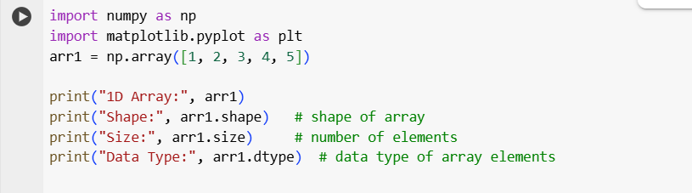

OUTPUT:

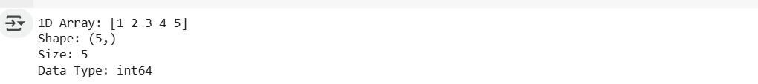
- Create two 2D NumPy arrays matrices and perform
- Element wise addition
- Transpose of a matrix
- Sum of all elements in the first matrix
INPUT:
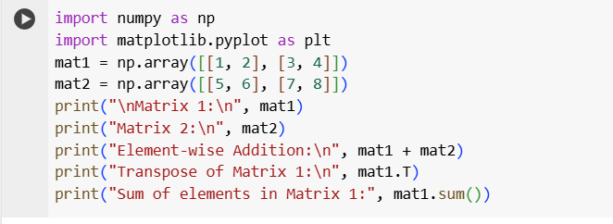

OUTPUT:
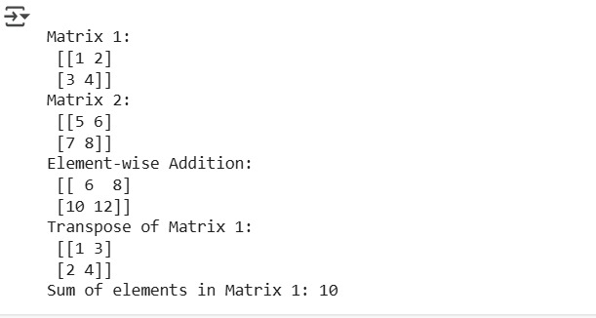

- Generate a NumPy array using arrange() and reshape it into a 3*3 matrix. Display the matrix.

INPUT:

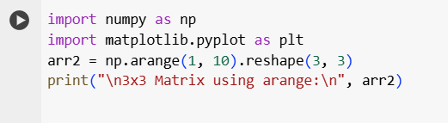

OUTPUT:

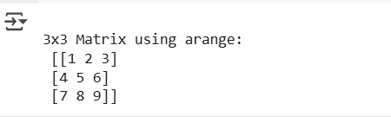

- Create a NumPy array of random numbers. Perform and display the results of:
- Slicing the array
- Finding mean and median
- Finding max and min values
INPUT:

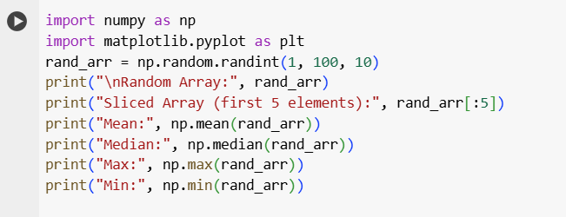

OUTPUT:
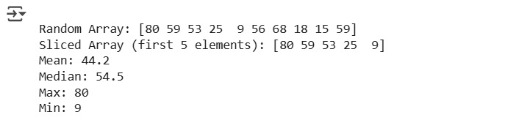

- Plot a line graph for x=[1,2,3,4,5] and y=[2,4,6,8,10]. Add title, x-label, y-label and grid.

INPUT:
import numpy as np
import matplotlib.pyplot as plt
x = [1, 2, 3, 4, 5]
y = [2, 4, 6, 8, 10]
plt.plot(x, y, marker='o')
plt.title("Line Graph")
plt.xlabel("X-axis")
plt.ylabel("Y-axis")
plt.grid(True)
plt.show()

OUTPUT:
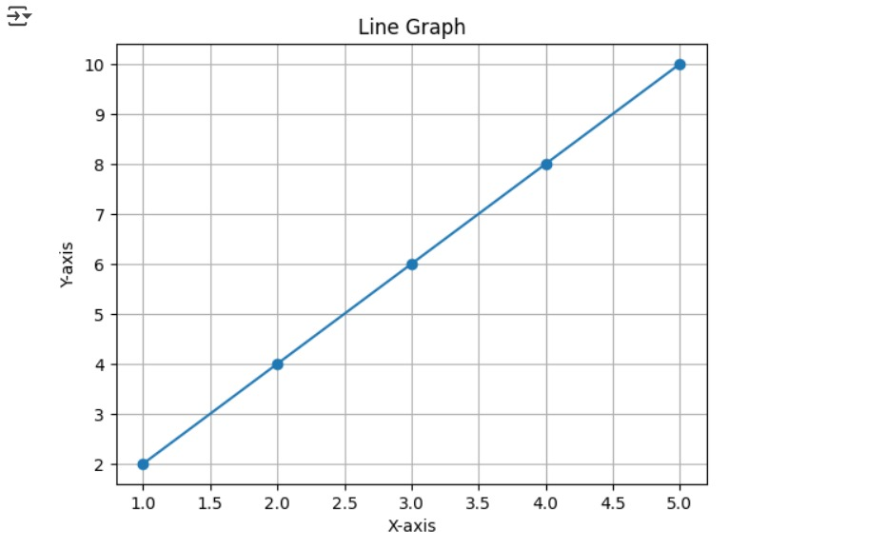

- Draw a bar chart showing the marks of students. Take 4 students names and their marks.
INPUT:
import numpy as np
import matplotlib.pyplot as plt
students = ["A", "B", "C", "D"]
marks = [85, 90, 78, 92]
plt.bar(students, marks, color=['blue', 'green', 'orange', 'red'])
plt.title("Student Marks")
plt.xlabel("Students")
plt.ylabel("Marks")
plt.show()

OUTPUT:

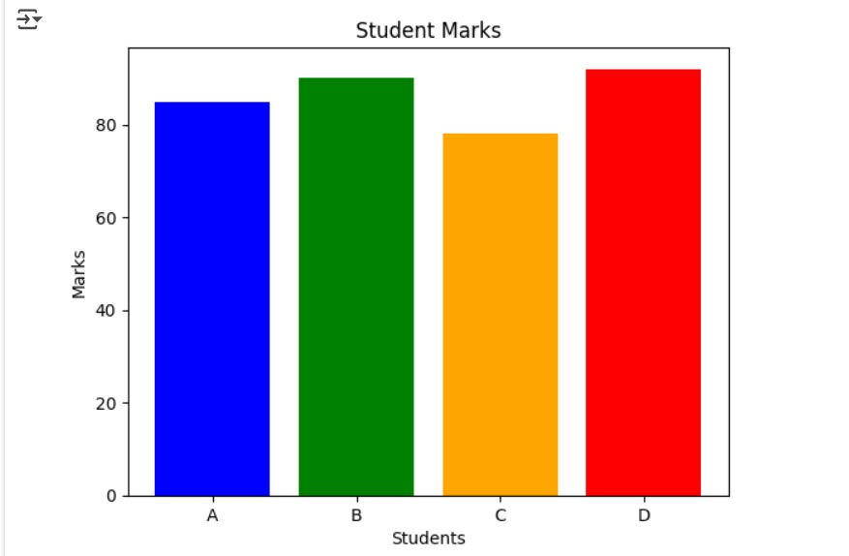

- Create a pie chart showing expense distribution in four categories. Food , rent, transport, and others. Display percentage on the chart.

INPUT:
import numpy as np
import matplotlib.pyplot as plt
expenses = [3000, 2000, 1500, 1000]
categories = ["Food", "Rent", "Transport", "Others"]
plt.pie(expenses, labels=categories, autopct='%1.1f%%')
plt.title("Expense Distribution")
plt.show()

OUTPUT:
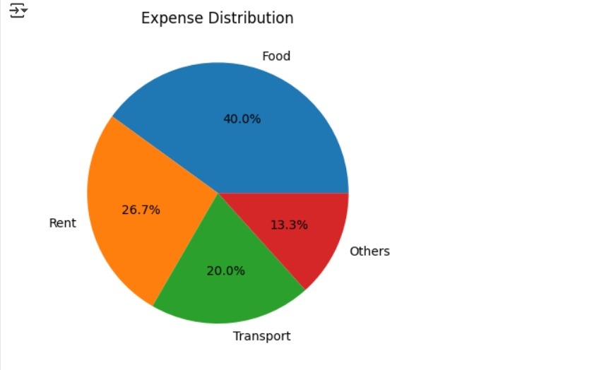

- Using NumPy and matplotlib plot a sine wave graph for the range 0 to 2pi using np.sin().

INPUT:
import numpy as np
import matplotlib.pyplot as plt
x = np.lin
space(0, 2*np.pi, 100)
y = np.sin(x)
plt.plot(x, y)
plt.title("Sine Wave")
plt.xlabel("x (radians)")
plt.ylabel("sin(x)")
plt.grid(True)
plt.show()

OUTPUT:

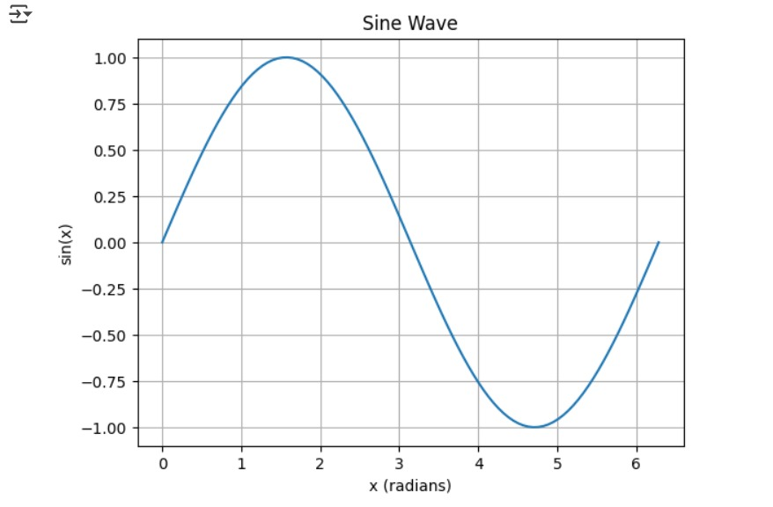

- Plot multiple lines on the same graph to compare two datasets (eg. Height vs weight for two different groups).

INPUT:
import numpy as np
import matplotlib.pyplot as plt
height = [150, 160, 170, 180, 190]
weight_group1 = [50, 60, 70, 80, 90]
weight_group2 = [55, 65, 75, 85, 95]
plt.plot(height, weight_group1, label="Group 1")
plt.plot(height, weight_group2, label="Group 2")
plt.title("Height vs Weight Comparison")
plt.xlabel("Height (cm)")
plt.ylabel("Weight (kg)")
plt.legend()
plt.grid(True)
plt.show()

OUTPUT:

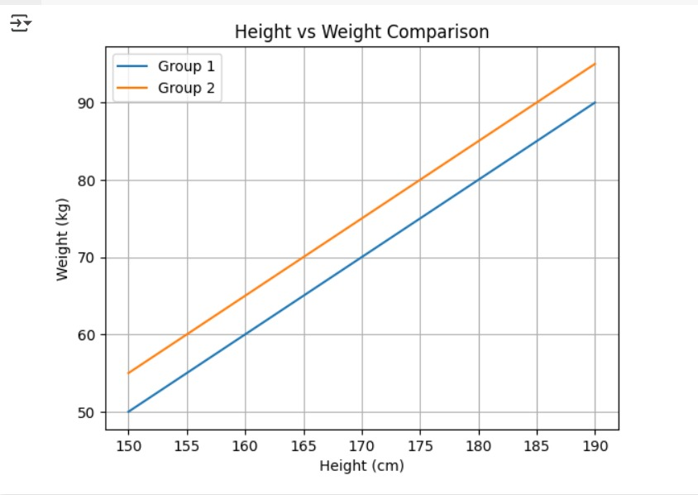

- Create a scatter plot using matplotlib for given values of x and y. add labels , title, and grid.

INPUT:
import numpy as np
import matplotlib.pyplot as plt

x = np.array([5, 7, 8, 7, 6, 9, 5, 6, 7, 8])
y = np.array([99, 86, 87, 88, 100, 86, 103, 87, 94, 78])
plt.scatter(x, y, color='purple')
plt.title("Scatter Plot Example")
plt.xlabel("X values")
plt.ylabel("Y values")
plt.grid(True)
plt.show()

OUTPUT:
